**Mrs. Taylor and Mrs. Rhea’s 4th Grade Syllabus**

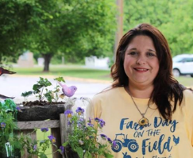Hi! And welcome to my 4th grade classroom. My name is Mrs. Taylor, and I will be your math and science teacher for the 2022-2023 school year. Here is a little information about me. I graduated from Augusta State University in 2010 with a Bachelor’s degree in Early Childhood Education then returned in 2015 to complete my Master’s degree in Curriculum and Instruction along with my gifted endorsement. Math and science are my favorite subjects to teach; so for that reason, I continued my training and earned my STEM endorsement from Middle Georgia RESA. Since then, I have taught Pre-k, 2nd, 3rd,4th, and 5th grade and served PK-5th grade students as a STEAM teacher. During that time, I was honored to be named Teacher of the Year for the 2018 school year at Goshen Elementary School. I am excited to start the new school year and be a part of the Blythe family!

Hello, fourth graders! My name is Mrs. Rhea, and I have been teaching for 26 years. This is my tenth year at Blythe. I am originally from Kentucky and did my undergraduate work there. I moved to Augusta for a teaching position in 1992. I completed my Masters of Education and Specialist Degree at Augusta State University and earned my Special Education Certification. I have taught Kindergarten, EIP Augmented, 2nd, 3rd, and 4th grades. In 2019, I was recognized as one of the top 5 finalists for Teacher of the Year for the Richmond County School System. I live in North Augusta, but I drive to Blythe every day. I truly believe it’s the best place to be as a teacher and as a student. I’m a Star Wars fan and I believe in Master Yoda’s saying, “There is no try, only do.” That simply means to willingly accept challenges and remember that education isn’t a race, it’s a journey.

**Communication**

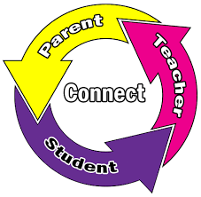We believe personal growth and perseverance are important parts of your child’s academic growth. We also believe in positivity and goal setting to promote success. In order to best support our students, we need to work as a team. We will be messaging parents via Class Dojo. You can download the app on your smartphone or log in to the website. Please check this daily as we will message parents personally and make class announcements. Also, you can always email your homeroom teachers at tayloje@richmond.k12.ga.us or rheaan@richmond.k12.ga.us.

Please notify your child’s homeroom teacher of any dismissal changes by sending a note with your child. If it is a last minute change, please notify the office as we cannot guarantee that we will get your Dojo message or email in time.

Notes can also be sent in your child’s communication folder. However, we will not be checking it daily. It will be your child’s responsibility to deliver the notes to his/her homeroom teacher during arrival each morning. This folder needs to be checked and cleaned out at home on a regular basis as completed student work will be sent home frequently.

**Absences/Tardies**

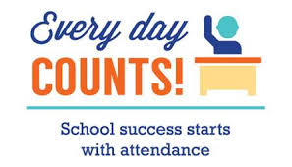Attendance is always necessary to ensure success. Your child must be an active participant in class every day. However, sickness and family emergencies do occur. We will send home any work your child needs to make up upon his/her return to school. Please be sure to send a note with your child when they return, and we will deliver it to the office. Our instructional day begins at 8:20. Students who arrive after 8:30 will be considered tardy.

**Learn-At-Home Policy**

****During Learn@Home Days, all students are expected to continue learning and demonstrating mastery of their content. Students will need an environment that is comfortable and distraction-free. Students are required to complete a work packet that is assigned by their teacher. These Learn@Home work packets will be graded; therefore, failure to complete and return these packets will negatively impact your child’s grades. At this time, Learn@Home days will take place on September 6th, February 21st, and March 14th.

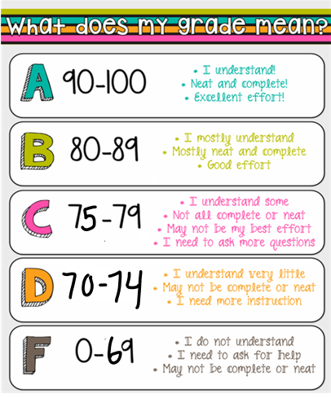

**Grading Policy**

Classwork, quizzes, and virtual (learn-at-home) assignments (minor assignments) will count as 60% of the grade. Tests and projects (major assignments) will be counted as 40% of the grade. This is the policy for all subject areas. All projects, such as Science and Social Studies projects, will count as two test grades. Please note that students will be required to complete a science project **at home** this year.

**Behavior Policy**

 Students are expected to follow our PAWS guidelines for face-to-face or virtual instruction. Student conduct grades will be determined by the following guidelines:

* (P) Positive Attitude: Using kind words and give best effort in class
* (A) Act Responsibly: Be prepared for class and ready to learn
* (W) Work for Success: Stay on task, do your personal best, participate fully, and complete work in a timely manner.
* (S) Show Respect: Follow teacher’s directions and use positive language with everyone.

We will be using an online management tool called CLASS DOJO to track students’ positive and negative behaviors. This program is based on points, and students can be given positive points for things like being on task, being respectful, participating, or working hard. On the other hand, points can be taken away if students are off task, talking out, or unprepared.

This is our primary way of communication, so please be sure to create a parent account and link your account to your 4th grader. You will be able to keep track of student behavior by logging in to CLASS DOJO and tapping on “Reports”.

**4-H Program**

****We are excited that Blythe students will be given the opportunity to participate in 4-H this year. Throughout the year our 4-H representative, Mrs. Hockenberry, will conduct 4-H lessons during the school day. There will be opportunities for clubs and activities outside school; however, these are optional. The 4-H curriculum strongly supports our learning targets in all subject areas. More information regarding dates and times will be sent home as soon as a schedule is confirmed.



**Homework Policy**

The following items will be part of the 4th grade homework expectations:

* I- Ready- I-Ready is our countywide diagnostic testing and intervention program. It is designed to identify your child’s strengths and weaknesses. It is strongly recommended that students spend 45 minutes in each subject, reading and math, each week. Please make sure that your child works on i- Ready lessons about 15-20 minutes each night.
* Math Practice sheet- This will go home each Monday in your child’s communication folder and is to be completed daily. It will be due each Friday.
* Math Fact Fluency- Students will need to know all multiplication and division facts with speed and accuracy. A math fact fluency packet will be in your child’s communication folder and will be signed off by Mrs. Taylor has he/she progresses. Students will be tested on their timed factsbi**-**weekly.
* Reading Fluency Sheet- Students will be expected to read the fluency passage and answer the daily questions each night. This will go home each Monday in your child’s communication folder and is to be completed daily. There will be a midweek check on Wednesday to answer any questions that may arise. It will be due on Friday.
* Spelling Choice Board- Students will be assigned spelling words each week along with a choice board. They will be required to complete 3 activities of their choice. This should be completed and turned in by Friday.
* Science and social studies will be assigned as needed. Students will complete projects throughout the year.

Assessments will be administered throughout the year. Notices about upcoming tests and quizzes will be sent via Class DoJo. Students will be given appropriate study/practice materials to take home in their communication folder.

**Georgia Standards of Excellence for 4th Grade**

**Math:**

During the first semester, we will be focusing on the following concepts:

* Fluently adding and subtracting within 1,000
* Solving multiplication and division word problems within 100
* Fluently multiplying and dividing within 100 on paper and from memory
* Solving multi-step addition and subtraction word problems within 1,000,000
* Place value with numbers within 1,000,000
* Multiplying and dividing whole numbers using multiple strategies
* Equivalent fractions and comparing fractions with different numerators and denominators
* Adding and subtracting fractions with mixed numbers
* Multiplying a fraction by a whole number

(These concepts will be continuously reviewed throughout the year.)

During the second semester, we will be focusing on the following concepts:

* Use decimal notation for fractions with denominators 10 or 100
* Compare two decimals to hundredths
* Classify shapes by their properties of the lines and angles
* Measure lengths with halves and fourths/line plots
* Understand fractions on a number line

**Science:**

During the first semester, we will be focusing on the following concepts:

* Investigating physical attributes of stars and planets
* Creating a model to demonstrate the effects of the position and motion of the Earth and moon in relation to the sun
* Investigating the water cycle
* Predicting weather events by inferring from weather patterns
* Evaluating weather charts and maps; collecting data
* Investigating the relationship between balanced and unbalanced forces

During the second semester, we will be focusing on the following concepts:

* Investigating sound production/change and how light and sound can be used to communicate
* Creating models to show the roles of organisms and the flow of energy within an ecosystem

**English/Language Arts:**

During the first semester, we will be focusing on the following concepts:

* Determining the theme, main idea, and key details of a story
* Summarizing texts and citing details from a text
* Making inferences, understanding compare/contrast and cause/effect relationships
* Writing narratives and informative texts.

During the second semester, we will be focusing on the following concepts:

* Explaining major differences in poems, prose, and drama
* Understanding text structure and features
* Read and comprehend literature and informational text
* Write opinion pieces

**Social Studies:**

During the first semester, we will be learning about:

* How our nation was formed to include cause of the American Revolution and explaining the Declaration of Independence
* The challenges of a new nation to include the Articles of Confederation, The Constitution, Government checks and Balances, and the Bill of Rights.
* The Nation Expands to include the War of 1812, Westward Expansion, and the Abolitionist and Suffragist Movements.

During the second semester, we will be learning about:

* The Civil War, its causes and major events and effects of the war
* Reconstruction after the war and economics.

**Please understand that many reading strategies overlap and are taught throughout the year. The timelines above are a guide. Lessons will be determined based upon what students already know and what they need further assistance to learn.**

